# Equipment

## Introduction

We have the perfect HMS GUI , but it will not work without good sensors. We have tested a lot of sensors and came up with the following recommendations. These sensors are mandatory for the proper functioning of the system.

## Extra equipment

An external gyro, GPS, log and depth sensor need to be connected. The communication should be based on the NMEA0183 protocol and all this data needs to be available in 1 NMEA0183 string.

## Barometer

For the barometer we recommend the Vaisala PTB330. It provides reliable pressure measurement in a wide range of applications. Digital outputs RS232 and RS422/485 (optional) can be selected. There is also a local digital display available.



*: For more information we refer you to the Vaisala PTB330 manual*

The vaisala PTB300 will be connected to the serial port of a moxa that is connected to the NavVision system. In NavVision you can go to tools/configuration/serial/serial lan ports and there choose the vaisala PTB330 protocol from the drop down menu (see Figure 2‑1). For more information on how to install and set-up the Moxa, we refer you to the “software installation and commissioning manual”.

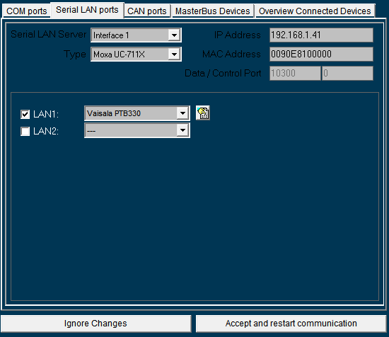

Figure 2‑1: Vaisala PTB330 on moxa

## Wind speed and direction

For wind speed and direction we recommend the Vaisala WMT700. Vaisala WINDCAP® Ultrasonic Wind Sensor WMT700 Series is a robust and reliable ultrasonic anemometer. It measures surface wind, which is one of the key parameters for meteorology and aviation.

The WMT700 Series meets the updated - WMO-No.8 guide, 7th edition - and ICAO requirements.



*: For more information we refer you to the Vaisala WMT700 manual*

The vaisala WMT700 will be connected to the serial port of a moxa that is connected to the NavVision system. In NavVision you can go to tools/configuration/serial/serial lan ports and there choose the vaisala WMT700 protocol from the drop down menu (see Figure 2‑1). For more information on how to install and set-up the Moxa, we refer you to the “software installation and commissioning manual”.

## Pitch, roll, sway and heave

For pitch, roll, sway and heave we recommend the Ship motion SMC108. SMC has developed its IMU range of Motion Sensors to meet the requirements of the marine sector. The IMU range provides high accuracy motion measurement data in dynamic environment in all areas from small hydrographic vessels to large oil rigs in all weather conditions.



*: For more information we refer you to the SMC108 manual*

The SMC108 will be connected to the serial port of a moxa that is connected to the NavVision system. In NavVision you can go to tools/configuration/serial/serial lan ports and there choose the NMEA protocol from the drop down menu (see Figure 2‑1). For more information on how to install and set-up the Moxa, we refer you to the “software installation and commissioning manual”.

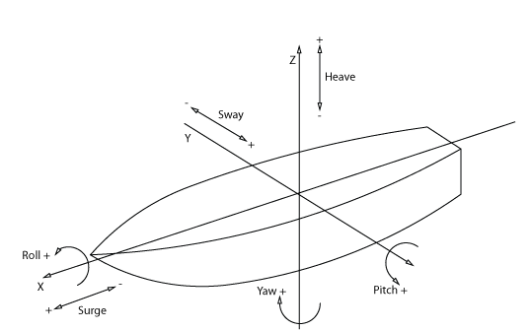

Figure 2‑2: Ships movement explained